

**A PROJECT REPORT**

**ON**

### JARVIS: THE PERSONAL Desktop Voice Assistant

### SUBMITTED BY-

|  |  |
| --- | --- |
| Bhosale Vaishnavi Satish | 04 |
| Dushing Akshada Saharam | 06 |
| Gunjal Shubhangi Sampat | 12 |
| Jadhav Vishal Walmik | 40 |

Submitted To-

MR.C. D BAWANKAR

MR.Y. S DESHMUKH

**DECLARATION**

We do hereby declare that the report entitled “Jarvis-Personal-Desktop-Assistant” submitted by us to Sanjivani College of Engineering, Kopargoan in “PYTHON MINI-PROJECT” is a record of bonafide project work carried out by us under the guidance of Mr C. D.Bawankar and Mr.Y.S.Deshmukh.

Place-Kopargoan

Date-2 June 2021.

**ABSTRACT**

The project aims to develop a personal-assistant for Windows based

systems. Jarvis draws its inspiration from virtual assistants like Cortana

and Siri. It has been designed to provide a user-friendly interfacefor

carrying out a variety of tasks by employing certain well-defined

commands. Users can interact with the assistant either through voice

commandsor using keyboard input.

As a personal assistant, Jarvis assists the end-user with day-to-day

activities like general human conversation, searching queries in google,

searching for videos on YouTube, to play music, open their favourite site

by just giving a voice command*.* The user statements/commands are

analysed to give an optimal solution.

**Aim-** To make a free source personal desktop assistant for windows

**Languages used**- Python

**Editor**- Visual Studio Code

**INTRODUCTION –**

We all had the similar thought before we started making our very own “Digital” Personal Assistant. Though it is not as capable and high as like Amazon’s Alexa or Google Assistant, Home or Apple’s Siri.

Nowadays, People are troubled by typing commands into the computer. Be it procrastination or a busy schedule. Typing is a big obsolete process. The solution to this is that we switch over to an assistant which understands us and do the initial work for us.

An assistant is the best replacement for typing commands. It’s named as Desktop Voice Assistant JARVIS with Voice Recognition Intelligence, which takes the user input in form of user’s voice and processes it and return the output in various ways like an action to be performed or the search result is spoken out to the end user.

**METHODOLOGY –**

You’ll need Python 3.6. We’ll be using the pyttsx3 package which is a text-to-speech library

for Python. The basic reason why we use this is because it works offline. Another basic

requirement of this project will be Python’s Speech Recognition library. There are other

requirements for the project which are listed below; we’ll understand them as we go ahead.

Inappropriate college description is also conveyed as all terms and conditions of college are

not known to students.

The overall system design consists of following phases:

1. Data collection in the form of user’s voice

(b) Voice analysis and conversion to text

(c) Data storage and processing

(d) Generating the task to be done from the processed text output

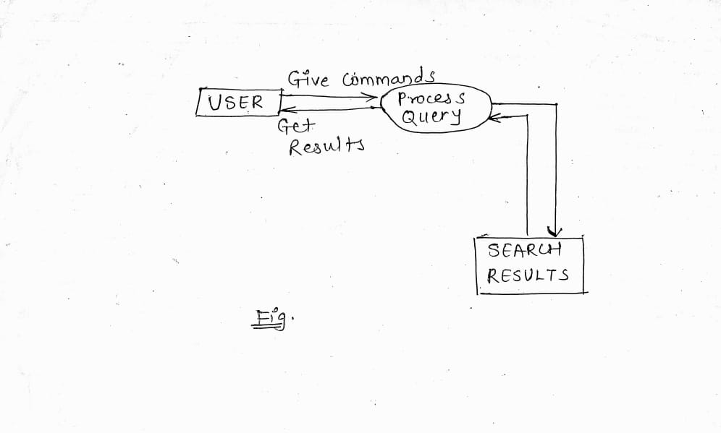

Fig. The data flow process in the JARVIS takes according to the above diagram

**FEATURES IN JARVIS**-

1.Search anything from Wikipedia-

JARVIS contains the Wikipedia module imported which helps user to get any information

from Wikipedia just by giving a query as an input through voice…

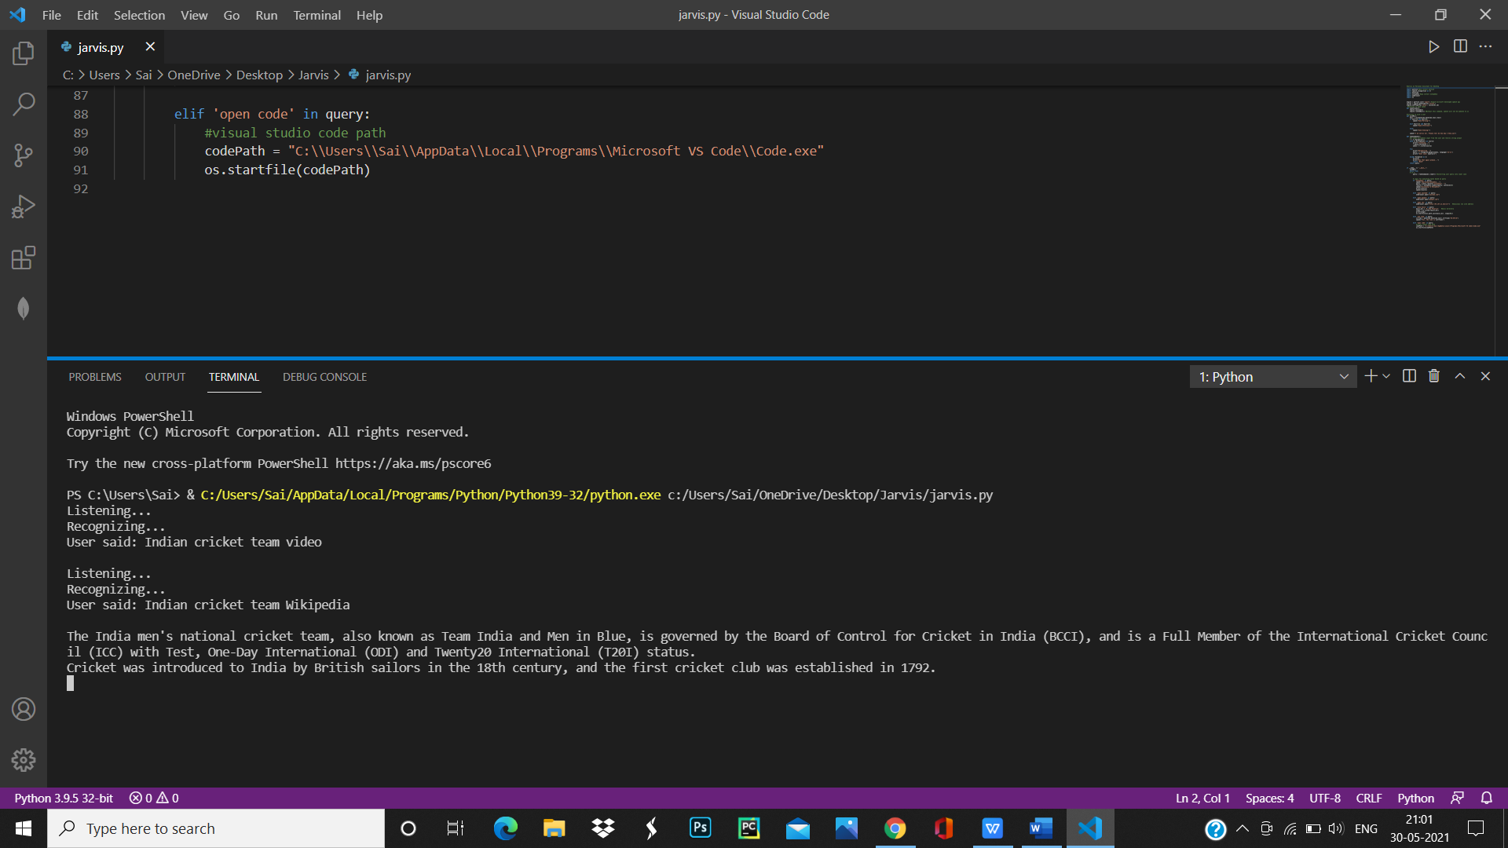

2. Open YouTube videos –

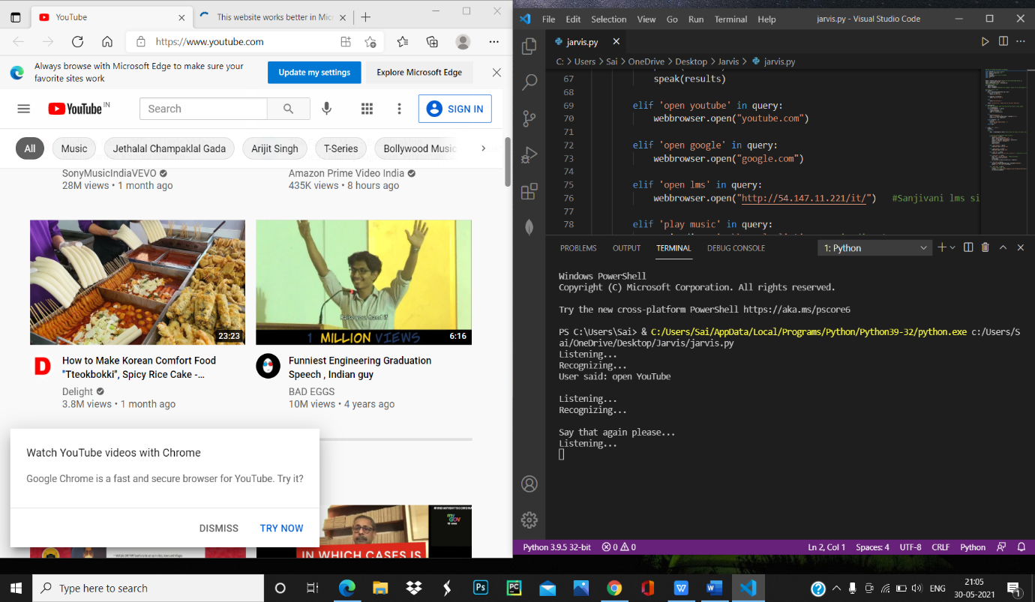

3.Open Sanjivani LMS-

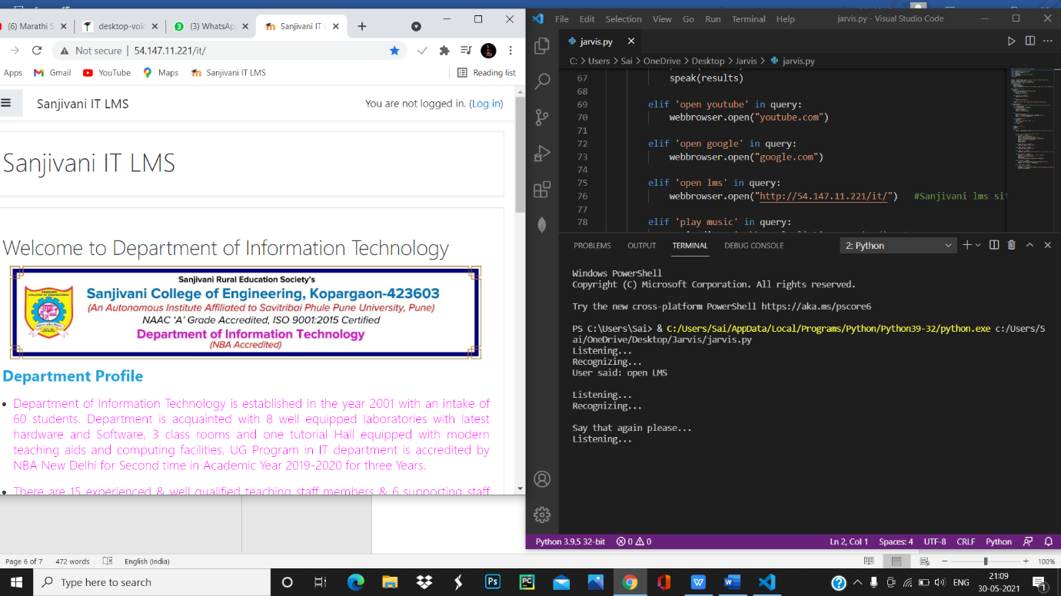

4.It can open any site from mentioned by the user using the web browser module

5.It can play music from the systems library.

6.JARVIS can also open any app or program in the system.

**CONCLUSION**-

The main aim of the project was to develop a Desktop Assistant that will be used to identify

answers related to user submitted questions. To provide with sufficient information that is

required by the user. A background research took place, which included an overview of the

conversation procedure and any relevant desktop Assistant available. A desktop Assistant

already in user were excellent service that is provided.

**ACKNOWLEGEMENT-**

We owe a debt of sincere gratitude, and respect to our guide and mentor Mr Chetan

Bawankar and Yogesh Deshmukh, Professor, SCOE, Kopargoan for their sagacious guidance,

vigilant supervision and valuable critical appreciation throughout this project work.

We express profound gratitude and heartfelt thanks to Dr.Madhuri Jawale, HOD IT, SCOE

for her support, suggestion and inspiration for carrying out this project.

**REFERENCE-**

[1] “Desktop Assistant from Wikipedia,” https://en.wikipedia.org/wiki/Desktop Assistant,

[2] Richard Krisztian Csaky, “Desktop Assistant and related Research paper Notes with Images,” https://github.com/ricsinaruto/Seq2seqDesktop Assistants/wiki/Desktop Assistant-and-RelatedResearch-Paper-Notes-eith-images,

[3] Yosua Alvin AdiSoetrisno, “Ticketing Desktop Assistant Service using Serverless NLP Technology,” http://www.academia.edu/Documents/in/Desktop Assistant,

[4] “Potential benefits of Desktop Assistants,” https://www.convinceandconvert.com/wpcontent/uploads/2018/01/Critical-Desktop Assistant-Statistics-2018-2-e1516922252367.jpg,

[5] “Desktop Assistant Theory Explained,” https://www.geeksforgeeks.org/Desktop Assistant-theoryexplained/, [6]

[6] “Code with harry” codewithharry.com